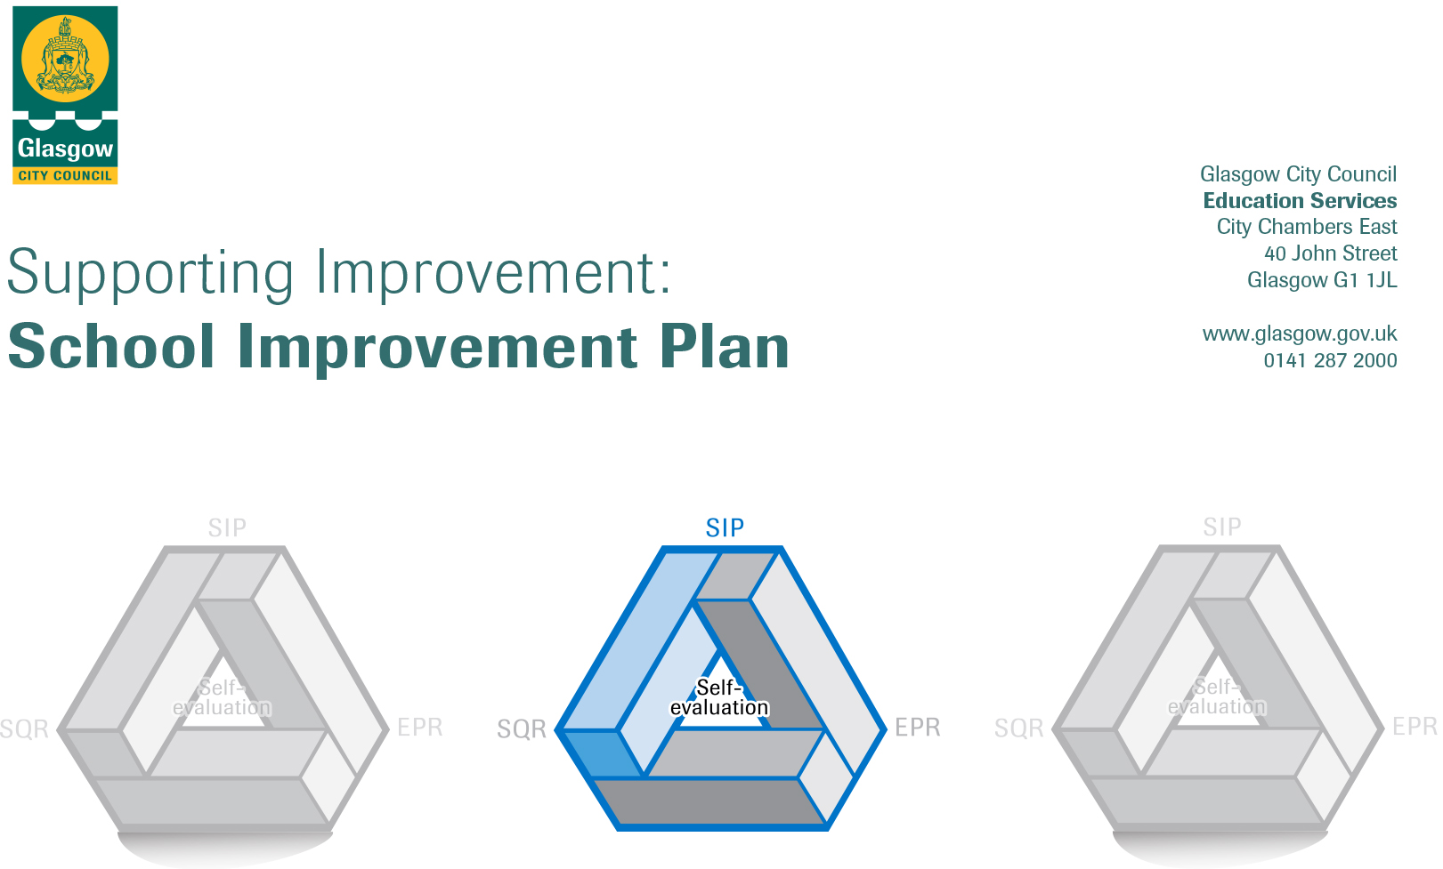

Session: 2019-20

Establishment |  | Langa Street Nursery School
Head of Establishment |  | Kate Lennie
Area/Local Improvement Group |  | North West Lig1
Head of Service |  | Jim Wilson
Area Education Officer/  Quality Improvement Officer |  | Rachel Binnie. David Byrne

CONTENTS
1. Vision, Values and Aims
2. Summary of Self-Evaluation Process / Priorities for Improvement in the current session
3. Action Planning

Action Plan Summary for Stakeholders

1. Our Vision, Values and Aims
At Langa Street Nursery School, we want the best for our children, parents and staff. We will create a nurturing environment, where we learn and grow together, to be the best we can.

Values
The best interests of children are promoted throughout the nursery.
We value and celebrate our rich cultural heritage.
The views of children, parents, partners and staff support improvements.
The nursery promotes openness, honesty, trust and kindness.
Aims
To provide a safe, healthy and motivating learning environment.
To provide a warm and welcoming atmosphere, which promotes inclusion, fairness and respect
To help children to develop as confident, caring, independent learners

2. Summary of our self-evaluation process.
Our self- evaluation is focused on key aspects of children’s successes, achievements and well-being.
There continues to be a focus on improvements to learning and teaching and also in the way we recognise and celebrate the successes and achievements of all children and our engagement in family learning.
Questionnaires, comment slips, and ongoing discussion are used to seek feedback and suggestions for improvement from parents and staff help us plan future programmes.
Parents who took part in our school transition workshops this year provided positive feedback, telling us how useful the meetings were. Almost all our school leaving parents responded to our exit survey and
told us they agreed or strongly agreed that they enjoyed the experience of being part of their child’s learning and development at Langa Street Nursery.

Strengths identified:

- Our vision is based firmly on high quality early learning and care for our children. We work hard in order for all our children to become successful, confident learners who achieve across a range of areas.
- A continued strong focus on health and wellbeing ensures this is embedded in daily practice and has a positive impact on children’s learning.
- Our strong ethos, shared values and strong commitment to team work is evident in the very good relationships that exist between staff and also with parents and children. We value the views of our service users and strive to use this information to improve our service.

Priorities for development:
1: Leadership of change
2: Numeracy and Maths
3: Recognition as a Language and Communication Friendly Nursery

3. Action Planning

No. | Quality Indicator | Priority Leadership of change
1 | 1.1, 1,3, 1.4, 2.7 | Develop our provision in order to meet the needs of our children and families in line with the priorities laid out for Early Learning and Childcare in the new National Standard for expansion in 2020

Tasks to achieve priority | Timescale  and checkpoints | Evidence of Impact > (data, observation, views)
Introduction of extended day service, including new staff working pattern in place, ensuring effective delivery of 900 hours provision for entitled children and families | Term 1-4  Aug 19- June 20 | Self-evaluation through gathering staff feedback, parent’s views, and observations of children and children’s questionnaires will inform us if the pace of change is having a positive impact on children’s well-being.
Review and revise current staff induction/mentoring/coaching programme to support all new staff required to implement changes. Contact ELC manager re new staff induction training. | Term 1  Aug 19- October 19 | Staff will have opportunities to provide feedback regularly on the effectiveness of induction and mentoring processes through team meetings and questionnaires aimed at ensuring continuous improvement.
Shared practice visits/discussions with SMT from a variety of early years settings to consider new ways in which to effectively implement pace of change. | Term 1-4  Aug 19- June 20 | Effective collaboration is taking place throughout our learning community and beyond in the form of LIG meetings and Early Years Heads meeting and forums to support SMT.
Evaluate the impact the proposed change will have on the pace of the day for staff and children, making amendments including any to the environment, to suit the needs of the children within the new extended hours and provision. | Term 1-4  Aug 19- June 20 | The successful implementation of meeting the proposed targets will be done with the collaboration and support from our change link manager, Cordia, ELC manger and HR, and will have an impact on improvements for our children and families.

Staff leading on this priority – including partners | Resources and staff development
Head of Nursery Kate Lennie  Team Leader Elaine Dutton  Practitioners  ELC manager Alison Bowers  Change Link Manger Annette Notaro | Questionnaire Feedback  CPD manager to support staff development  New Staff Induction Programme  Mentoring and coaching CPD  Additional financial support for resources and changes to environment  Timetable for good practice visits discussed with other senior leaders (Heads of Establishments in LIG)

 | Quality Indicator | Priority: Numeracy and Maths
2 | 2.2, 2.3 | Raising attainment in numeracy and maths

Tasks to achieve priority | Timescale  and checkpoints | Evidence of Impact > (data, observation, views)
Glasgow Count Numeracy Trackers Introduction to practitioners | Term 1  August 2019 | We will use information gathered from trackers to ensure all practitioners are confident in making sound judgements around children’s progress and learning.
Glasgow Counts numeracy tracker training for practitioners | Term 1  August-Oct 19 | Team leader will lead staff training in this.  LEL will develop programmes to support this.  Feedback from staff to support self-evaluation.
Support joint working group with TL,LEL and LPA | Term 1-4  August –June 20 | Effective collaboration within LIG and LEL base. Opportunities for moderation within LC to be considered.
All practitioners to further develop their understanding, use and knowledge of early level numeracy benchmark | Term 1-4  August –June 20 | CPD sourced to ensure we have innovative and creative programmes in place to support early level numeracy.
Review of existing resources | Term 1  Aug 19 | Carry out extensive audit to ensure appropriate resources are in place to support children’s progress in numeracy and maths

Staff leading on this priority – including partners | Resources and staff development
Head of Nursery Kate Lennie  Team Leader Elaine Dutton  Practitioners  LEL support  John Paul LC  LIG | Budget managed to purchase resources  Team Leader training  Contact LEL to provide additional support  CPD manager/Twilight training sessions

 | Quality Indicator | Priority
3 | 2.3, 3.1 | Begin process of accreditation to become a Language and Communication Friendly Nursery
Tasks to achieve priority | Timescale  and checkpoints | Evidence of Impact > (data, observation, views)
Refresh current action plan in the five indicators to identify improvements required. | Term 1  Aug 19 | All practitioners will become aware of requirements for accreditation
All new staff to have individual mentoring support to allow them to become familiar with LCFE process. | Term 1  Aug 19 | Implementation questionnaire to establish knowledge and understanding of LCFE principles
Mentoring visit to support process | Term 1 Aug-Oct 19 | Areas of development addressed for all practitioners
Include Peer observations in self-evaluation process |  | Peer observations support practice and promote opportunities for speech language and communication for all children across all areas of the playroom.
Apply for funding from ELC Inclusion fund | Aug 19 | All language and communication will be enhanced with the use of Makaton and board maker signs
Request validation visit | Oct 19 | Awarded Language and communication friendly nursery status.

Staff leading on this priority – including partners | Resources and staff development
Head of Nursery Kate Lennie  Team Leader Elaine Dutton  All Practitioners  EP. Patricia Murray  Speech and Language link practitioner Jennifer Flemming  Language and Communication Friendly Validation Team | Management of budget to support CPD and resources  Develop CDP calendar to support practitioners developing skills  Mentor support  Accreditation

Tasks to achieve priority | Timescale  and checkpoints | Evidence of Impact > (data, observation, views)

Staff leading on this priority – including partners | Resources and staff development

