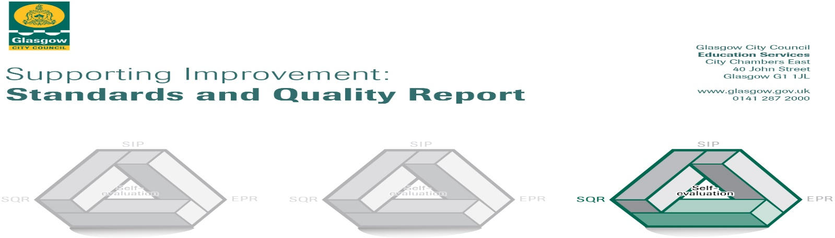

The summary report is provided for parents/careers and partners to outline our achievements this session and our priorities for next session. Throughout this session we have taken forward our priorities as detailed in our school improvement plan. Through our processes of self-evaluation, we have identified how we can improve outcomes for our children and young people.

Our achievements and improvements this year.
We would like to highlight the following improvements/achievements to you:
At Langa Street Nursery we want the best for our children, parents and staff. We aim to make this establishment a place where children are valued as individuals and where families feel welcome and included. We believe we can do this best by working in partnership with parents and other professionals. Each year we strive to improve the early learning and care we provide. This report tells you about what we think we are doing well, how we improved this session, and what we plan to work on in the coming year. We hope you enjoy reading our report. Thank you for your continued support and thank you to everyone who worked with us to make 2018/19 another great year at Langa Street Nursery.

Leadership of change:
The views of parents, children continue to support improvements and we would like to thank all our parents who completed surveys and questionnaires throughout the year. Through this feedback we know that our parents feel welcomed and valued, particularly at times of transition such as home to nursery or nursery to school. The Care Inspectorate graded us as being very good, and reported on the “kind, caring interactions between adults and children throughout the day” and “staff displaying a real understanding of children’s individual needs and personalities and being responsive to them” This recognises the very high commitment from all staff to support our children and families, and reaffirms our vision which is based on high quality early leaning and childcare. Throughout the coming year we will welcome new staff members to Langa Street and see the introduction of an extended day and year. Our commitment to improvement and change remains one of our highest priorities.

Developments in learning teaching and assessment
We are committed to improving on how we listen to and communicate with children, supporting their developing communication skills. Staff have been working closely with Speech and Language therapists and our link Educational Psychologist and have received training which will help us to achieve accreditation as a Language Communication Friendly Establishment. Through our continued work with Eco School Scotland we achieved our first green eco flag in December 2018.

Progress in supporting wellbeing and inclusion
Our commitment to creating a supportive ethos, where children and families are welcomed and valued remains a key priority for the nursery. We sensitively and respectfully promote the wellbeing of children, their families and each other. Children are supported by familiar adults who take time to get to know them well and they are settled, happy and thriving. Our established PATHS programme continues to support children to increase their confidence and develop an understanding of their own and of others emotions. Individualised plans are in place for any children who may require additional support. We place great emphasis on a child’s stage of development rather than age which allows children to learn at their own pace. Relationships with partner professionals from Education and health remain very good and our robust school transition programme ensures children leave well prepared for the move to school.
Progress in children’s learning
Across the nursery we have effective approaches that enable our toddlers and young children to develop their skills in literacy, numeracy and health and wellbeing. Conversations with parents, other professionals and each other help us to develop a shared understanding of how children learn. There is evidence of this across the different learning environments in the nursery.
Our team leader took part in ‘Glasgow Counts in our playroom’ training. This has allowed her to work alongside Glasgow’s Leaders of Early Learning to enable staff to make better judgements in assessing children’s progress in numeracy. This year we saw most of our children making good progress in numeracy and mathematics.

Here is what we plan to improve next year.
We will continue to work in partnership with you and would like you to share any ideas on how you could be more involved in the nursery or identify any ways in which we can improve the service.

We have identified three priorities for year 2019- 20:
- Leadership of change with a focus on implementing extended day and full year service.
- Raise attainment in Numeracy and Maths
- Gain recognition as a Language and Communication Friendly Nursery

How can you find out more information about our school?
Please contact us directly if you require further information or if you wish to comment on the report.

The contact e-mail address is:Headteacher@langastreet-nursery.glasgow.sch.uk
Our telephone number is:0141 946 3721
Our address is: 83 Langa St, Glasgow G20 0SQ

