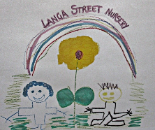Langa Street Nursery

Toothbrushing/ Oral Hygiene Policy

Rational

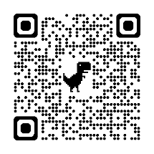In Langa Street Nursery we aim to include all children and consider individual needs regarding Oral Hygiene ensuring that we follow Glasgow City Council Policy and Child smile guidance.

The Child Smile Toothbrushing Programme aims to help children develop an important life skill at an early age. Ensuring the provision of at least 1000ppm fluoride toothpaste at home, and in nursery and school, means we can support a positive development in their immediate social and physical environment.

([www.childsmile.nhs.scot](http://www.childsmile.nhs.scot),2024)

Aim

* To ensure that children in our care are given the opportunity to be supported and develop self-care skills to look after their oral hygiene.
* To safeguard the rights and promote the health of all children.
* To provide guidance and reassurance for practitioners who are required to support children with oral hygiene children.
* To ensure parents/carers that practitioners are knowledgeable about health and personal care.

Practice

* All staff will have undergone training from child smile or their peers to support them with carrying out toothbrushing in the nursery
* All families will be informed and provided with guidance on the child smile programme at the enrolment stage of induction.
* Parents will give permission for their child to take part in child smile programme during enrolment induction.

Procedure step by step guidance

* Practitioners will ensure that the sinks are wiped and cleaned prior to starting toothbrushing with children and that they are wiped down with anti-bacterial spray between each child to prevent against contamination/infection
* Practitioners will apply PPE if required (open cuts on hands etc …)
* Practitioners will invite children in small groups of 2-4 children into the bathroom to brush their teeth- use objects of reference or board maker symbols to indicate direction/ instruction to all children
* Practitioners will support children to identify their toothbrush and practitioners will hand this to them
* Practitioners will give children the opportunity to collect their pea sized amount of toothpaste from the pallet/paper towel and apply it to their toothbrush
* A visual sand timer will be used to show children when to start and finish brushing their teeth.
* Practitioners will sing ‘toothbrushing songs’ identifying all areas the children need to reach with their toothbrush
* Once toothbrushing has ended the child will be encouraged to spit into the sink if they need to
* The child will rinse their brush independently
* The practitioner will place it back into the bus holder.
* This sequence will begin again with a new group of children until all children have been offered the opportunity.
* Practitioners will ensure at the end of toothbrushing that the sinks are wiped down with anti-bacterial spray and all lids are replaced on the brush buses.